**STUDENT NAME:** Nkhensile Mthombeni

**STUDENT NUMBER:** ST10477539

**MODULE NAME:** IMAD5112

**ASSGINMENT 1**

**MY FOOD APP**

I created an app that displays different types of foods during the time of day. A user can choose the morning, afternoon or evening. If the user doesn't select the correct information, it will display an error message.

**HOW IT WAS MADE**

I used Kotlin to create the app. I inserted two buttons, an edit text View, an image, and a display text.

One button is a submit button while the other button is a reset button

The submit button is like a select button

I added the different types of food for each time of day which is morning afternoon and evening. I added codes to make sure the app runs. I used different statements for different codes.

**HOW TO USE THE APP**

You open the app first then then click on the empty line and click the submit button to display the different meals of the day. Choose one option to display the different types of food of the selected meal. After choosing the meals click on the submit button again to confirm your choice of food. If you don't choose anything nothing will display.

LINKS

GITHUB: <https://github.com/NkhensileMthombeni/IMAD5112_Assignment-1>

YOUTUBE: <https://youtu.be/_03eHrRcGWk?si=Cs9_ZRg5A2RFFzcL>

[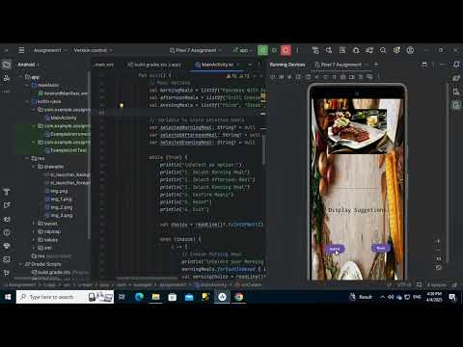](https://youtu.be/_03eHrRcGWk?si=Cs9_ZRg5A2RFFzcL)